

**University of Bahrain**

**Collage of Information Technology**

**Department of Computer Science**

**ITCS-444**

**SECTION 01**

**Comparison Application**

**Project domain:**

Our lives have moved digitally and we are increasingly relying more and more on digital equipment to support our current lifestyle. Sometimes, we would like to order online an item but we spend a lot of time searching and comparing similar items until finally deciding the suitable one in terms of budget and specifications. For example, a user would like to buy a laptop and they want to buy the one with best options, low option or value for money. To make the decision the user has to go over all offered laptops, read their specifications, and then make a decision. During this process, the user usually tends to create a shortened list that is more manageable for comparing and finally ordering. The user also sometimes would like to defer their purchase order until sale season. You are to design and implement a mobile app to facilitate support for customer satisfaction through user guidance. The app should be able to register user information, view items, search and filter items. Save my search preferences and respectively my filtered list. Allow for items comparison visually and automatically. Items are usually posted as image/s with text description. The app should be able to view side-by-side two or more items, extract item specification and features, highlight similar specifications/features, show differences, perform statistical analysis, short report. Example one, Amazon is a major online store. Search for laptop, extract few laptops and add them to your app manually (it would be better to perform automatic API search and extract). Allow the user to select and compare items. Example two, perform search for laptop on aliexpress website. Allow the user to select and compare retrieved items from both Amazon and aliexpress. Maybe it would be better to have a favorite list of items, from which you can select and compare. Save favourite lists, comparison reports and user comments too.

Your mobile-application implementation must demonstrate that you are able to decide which Mobile APIs including but not limited to (HTTP, Web Services/Firebase SQLite/local storage, Google Map, notifications, animation etc..) for each app function. User Interface, assistance and attraction are vital to the user.

**Login Page:**

**Register:**

**Welcome Page:**

**Side Menu:**

**Amazon Store:**

**Comments:**

**Star Ratings:**

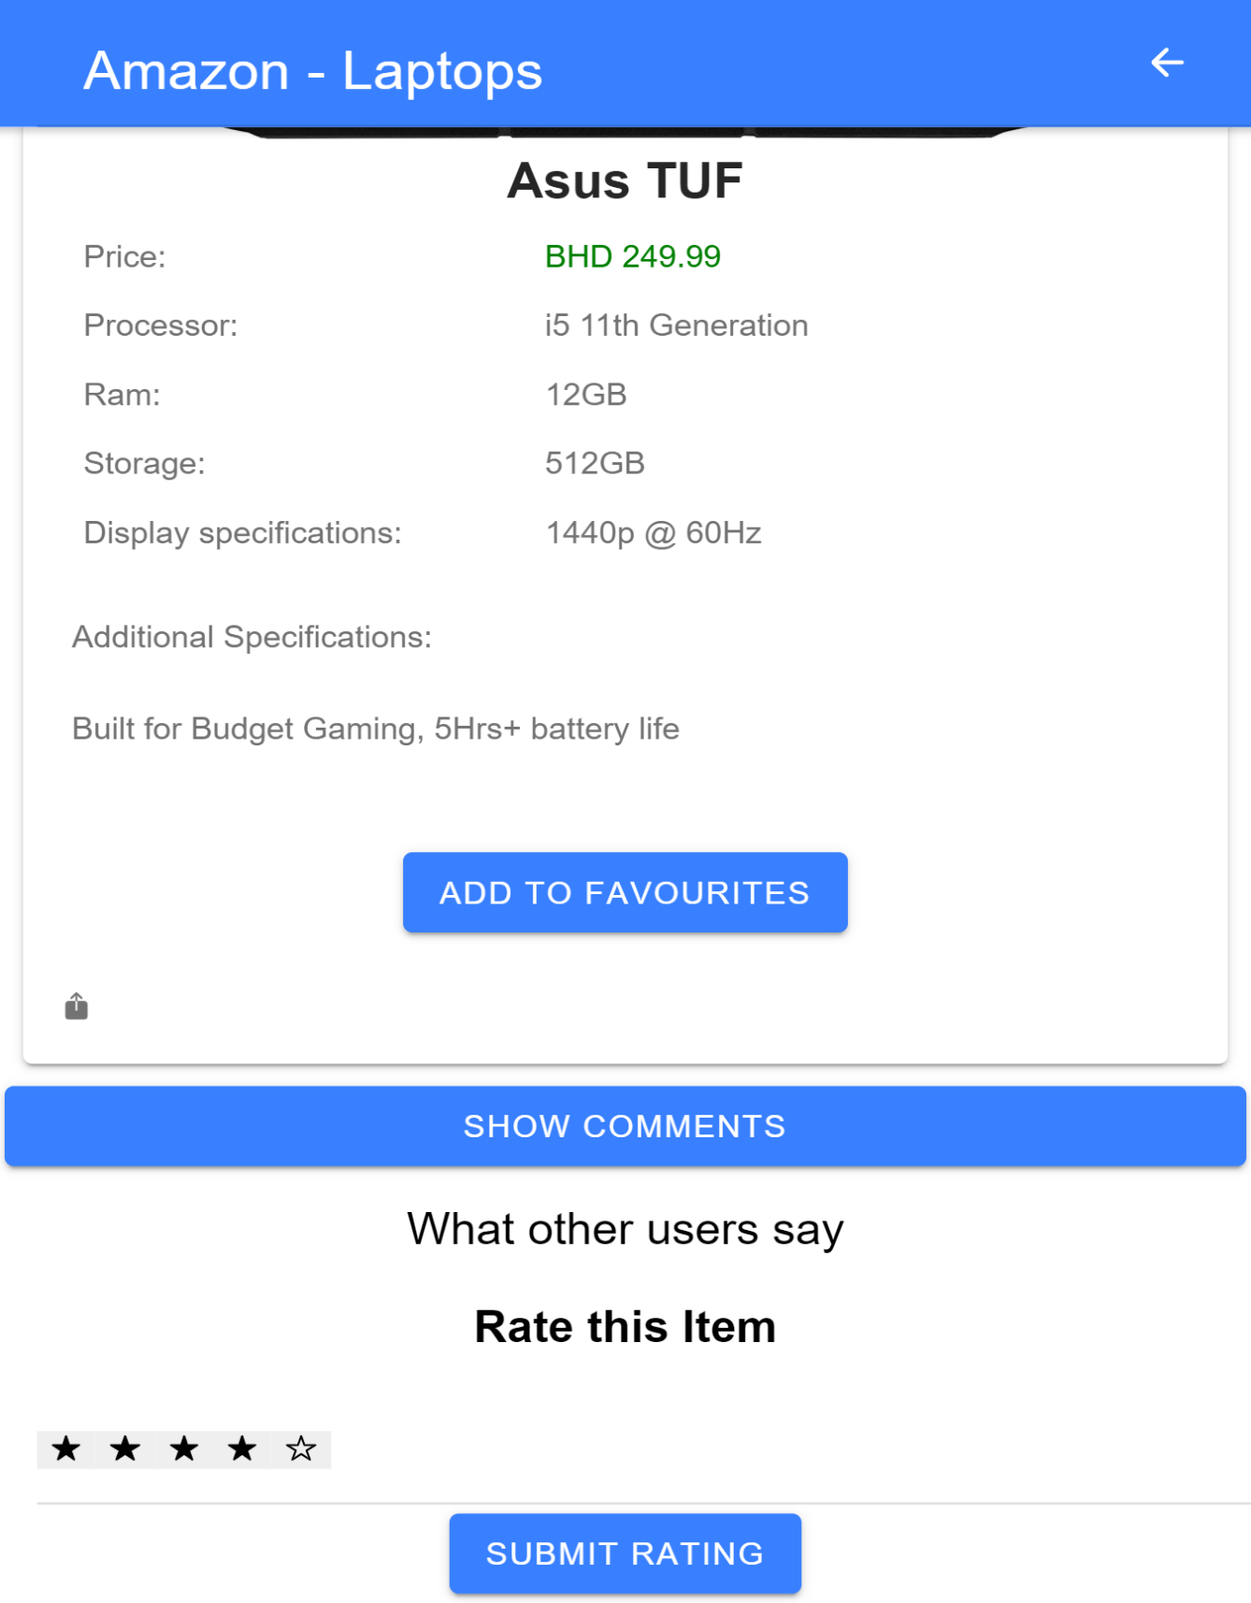

**Search Bar:**

**Ebay Store:**

**Mobile:**

**Comparison List of Mobiles:**

**Results Based on Comparison:**

**Comparison list of Laptops:**

**Favourites:**

**Mobile**

**Detailed Info about a Product:**

